**Workbench Tasks**

- Gather information from client regarding the services provided to Student, Parent, and Teacher.

- Add student services information to the Default Student Corner page.

- Design Parent Wraparound page to display parent services and information

- Design Teacher Connectivity page to display teach services and information.

- Create view details link under service description to allow user to skip to specific service section on page.

- Navigation link above footer allows user to revisit the Default About Us page to view other sources.

- Contact page has the option to send an email directly to the organization and to send physical mail to organization’s address. User can fill out contact form.

- Create a Teacher portal login page

- Create login form to allow teacher to enter username/password

- Create button link from Teacher Connectivity page that allows current teachers to login to teacher portal.

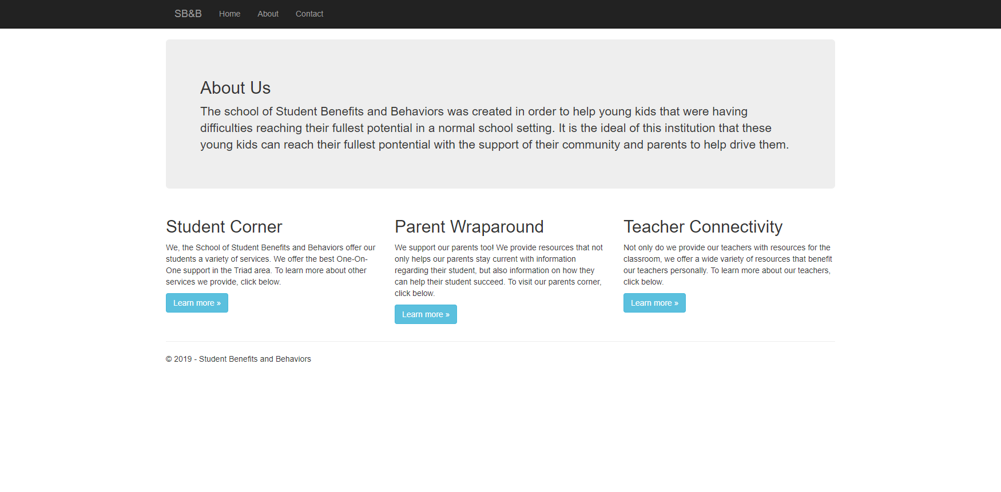

Figure 1: About Us Default Page with Organization Services

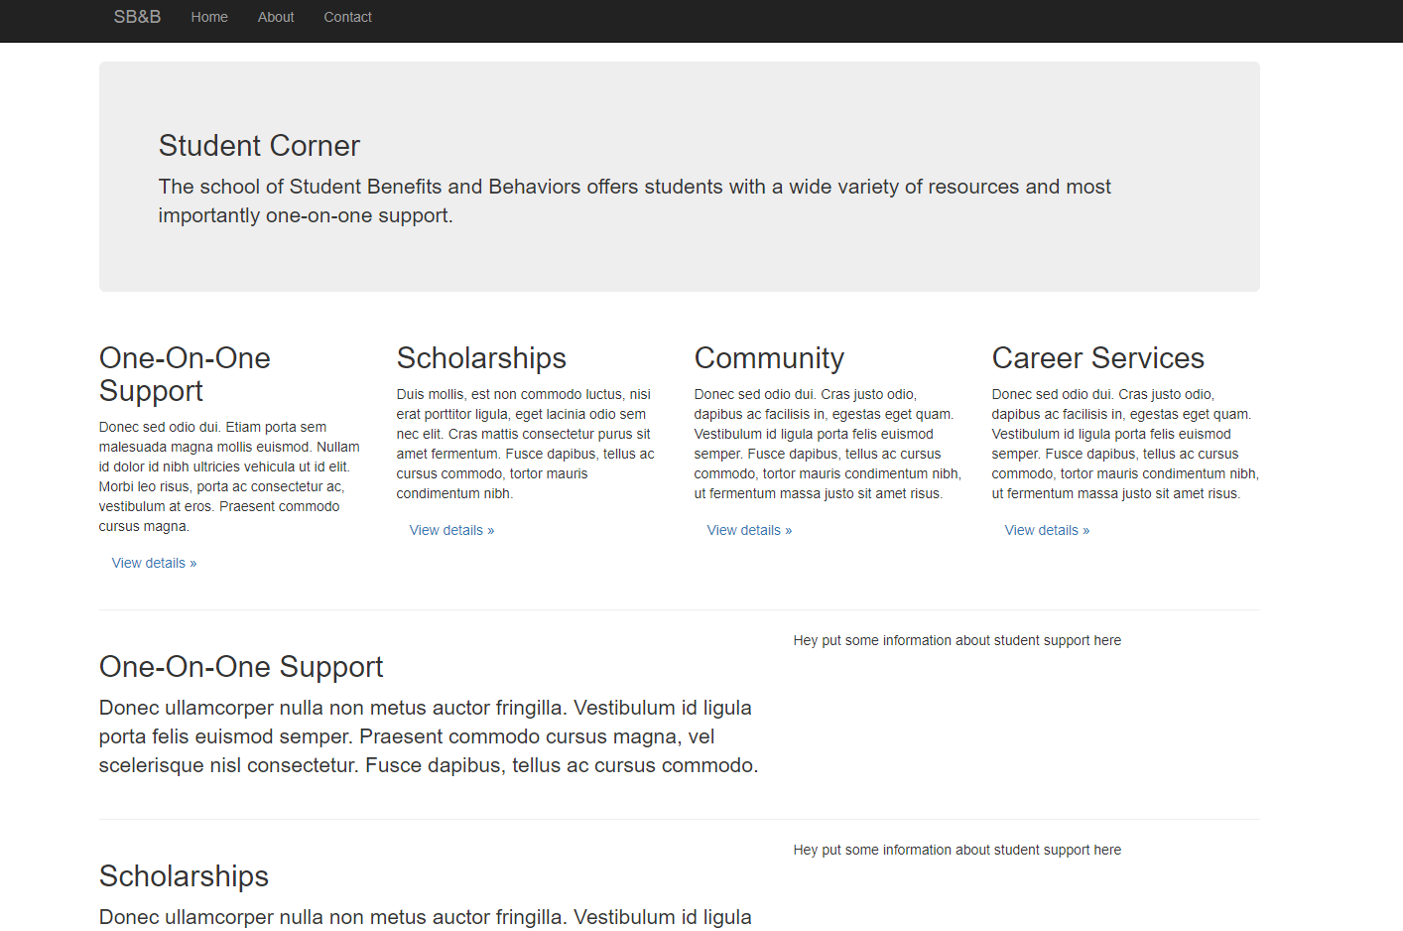

Figure 2: Student Corner Page

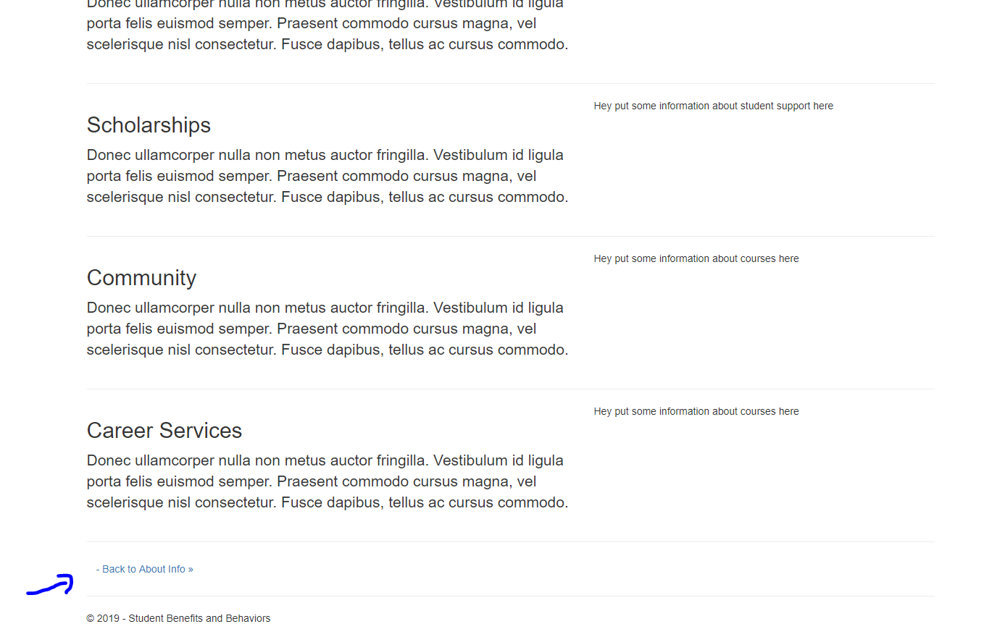

Figure 3: Student Corner Page Part 2 with navigation link: About Us Default Page

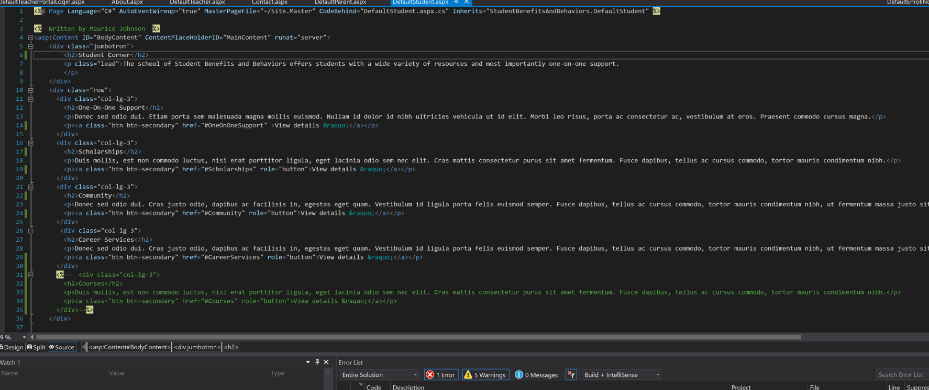

Figure 4: Student Corner Page Code

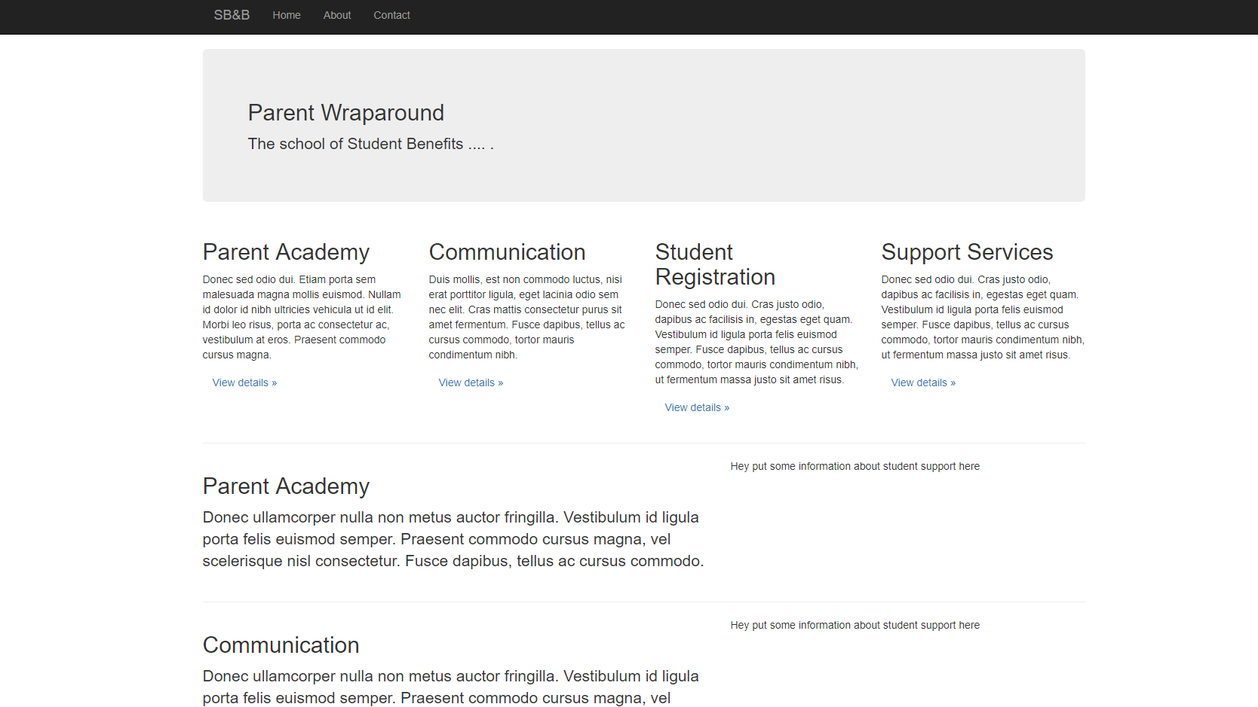

Figure 5: Parent Wraparound Default Page

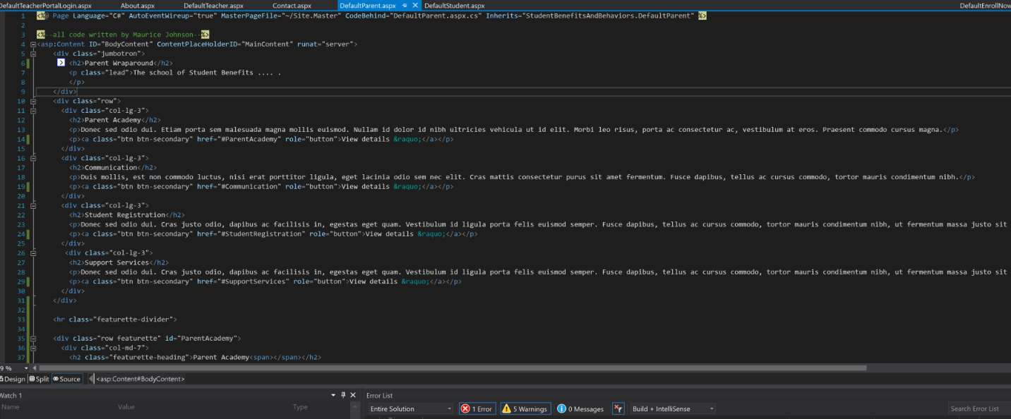

Figure 6: Parent Wraparound Default Page Code

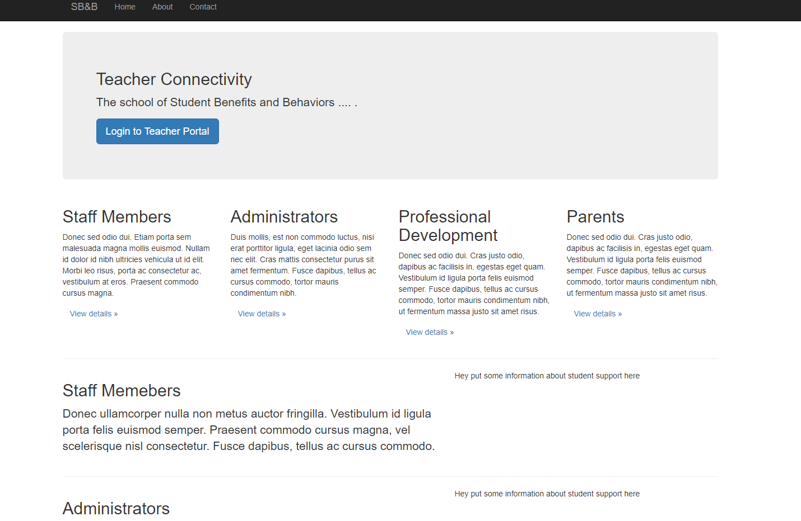

Figure 7: Teacher Connectivity Default Page

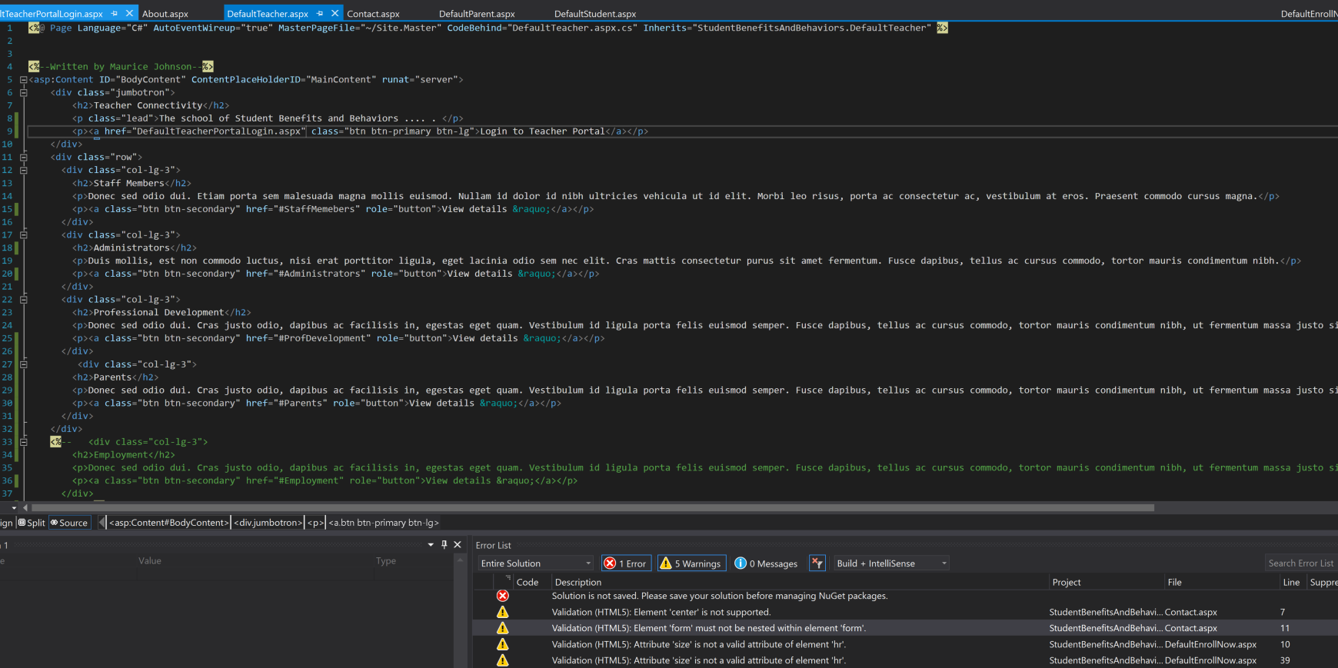

Figure 8: Teacher Connectivity Default Page

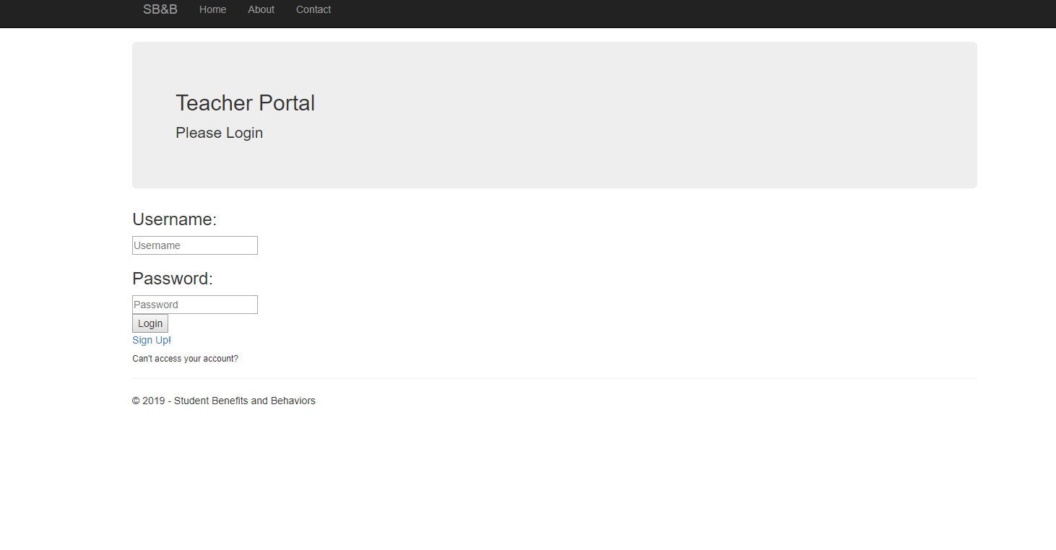

Figure 8: Teacher Portal Login Page

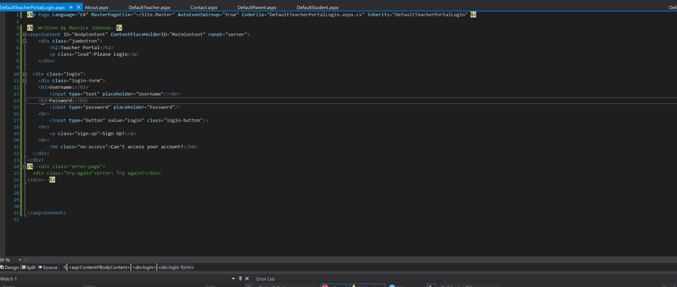

Figure 9: Teacher Portal Login Page Code

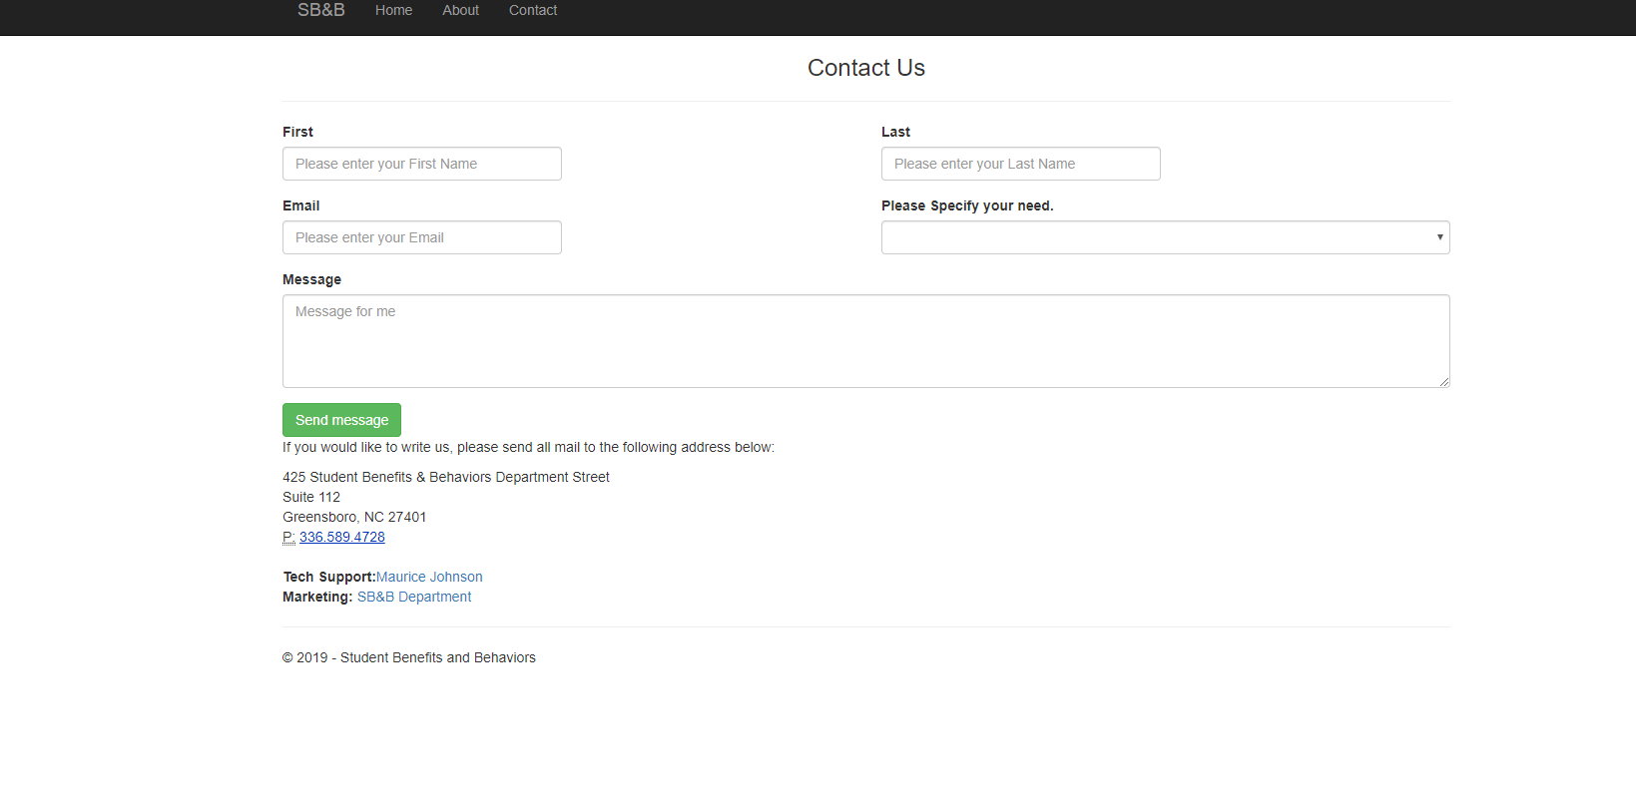

Figure 10: Contact Us Default Page with Contact Message Form

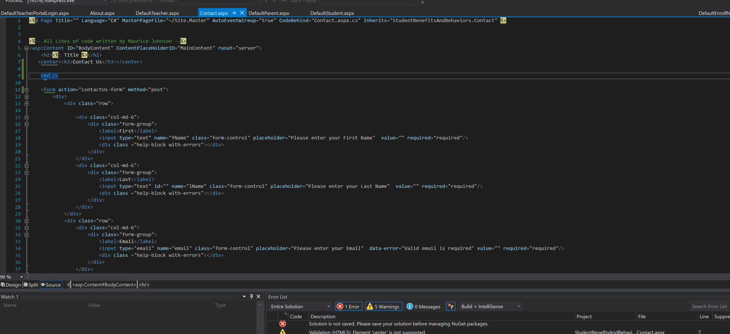

Figure 11: Contact Us Default Page with Contact Message Form Code